Week 06a: Search Tree Algorithms 1

Searching | 1/74
An extremely common application in computing
- given a (large) collection of items and a key value
- find the item(s) in the collection containing that key
  - item = (key, val₁, val₂, …) (i.e. a structured data type)
  - key = value used to distinguish items (e.g. student ID)
Applications: Google, databases, .....

... Searching | 2/74
Since searching is a very important/frequent operation,
many approaches have been developed to do it
Linear structures: arrays, linked lists, files
Arrays = random access. Lists, files = sequential access.
Cost of searching:
 | Array | List | File
Unsorted | O(n)  (linear scan) | O(n)  (linear scan) | O(n)  (linear scan)
Sorted | O(log n)  (binary search) | O(n)  (linear scan) | O(log n)  (seek, seek>, …)
- O(n) … linear scan (search technique of last resort)
- O(log n) … binary search, search trees (trees also have other uses)
Also (cf. COMP9021): hash tables (O(1), but only under optimal conditions)

... Searching | 3/74
Maintaining the order in sorted arrays and files is a costly operation.
Search trees are as efficient to search but more efficient to maintain.

Example: the following tree corresponds to the sorted array [2,5,10,12,14,17,20,24,29,30,31,32]:
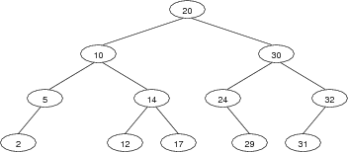

Tree Data Structures

Trees | 5/74
Trees are connected graphs
- consisting of nodes and edges (called links), with no cycles (no "up-links")
- each node contains a data value (or key+data)
- each node has links to ≤ k other child nodes (k=2 below)

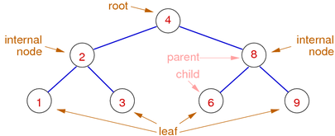

... Trees | 6/74
Trees are used in many contexts, e.g.
- representing hierarchical data structures (e.g. expressions)
- efficient searching (e.g. sets, symbol tables, …)

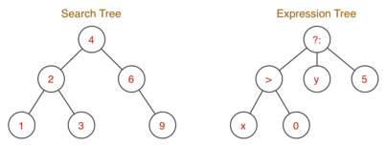

... Trees | 7/74
Trees can be used as a data structure, but also for illustration.
E.g. showing evaluation of a prefix arithmetic expression
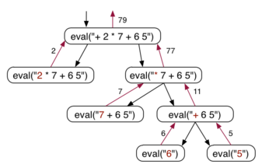

... Trees | 8/74
Binary trees (k=2 children per node) can be defined recursively, as follows:
A binary tree is either
- empty (contains no nodes)
- consists of a node, with two subtrees
  - node contains a value
  - left and right subtrees are binary trees

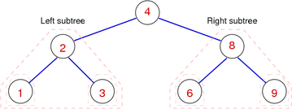

... Trees | 9/74
Other special kinds of tree
- m-ary tree: each internal node has exactly m children
- Ordered tree: all left values < root, all right values > root
- Balanced tree: has ≅minimal height for a given number of nodes
- Degenerate tree: has ≅maximal height for a given number of nodes

Search Trees | 10/74

Binary Search Trees | 11/74
Binary search trees (or BSTs) have the characteristic properties
- each node is the root of 0, 1 or 2 subtrees
- all values in any left subtree are less than root
- all values in any right subtree are greater than root
- these properties applies over all nodes in the tree
(perfectly) balanced trees have the properties
- #nodes in left subtree = #nodes in right subtree
- this property applies over all nodes in the tree
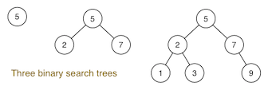

... Binary Search Trees | 12/74
Operations on BSTs:
- insert(Tree,Item) … add new item to tree via key
- delete(Tree,Key) … remove item with specified key from tree
- search(Tree,Key) … find item containing key in tree
- plus, "bookkeeping" … new(), free(), show(), …
Notes:
- nodes contain Items; we just show Item.key
- keys are unique (not technically necessary)

... Binary Search Trees | 13/74
Examples of binary search trees:
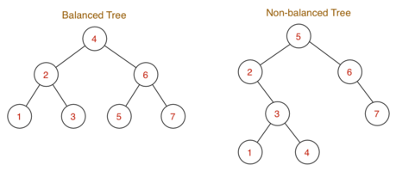
Shape of tree is determined by order of insertion.

... Binary Search Trees | 14/74
Level of node = path length from root to node
Height (or: depth) of tree = max path length from root to leaf
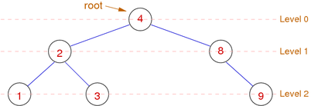
Height-balanced tree: ∀ nodes: height(left subtree) = height(right subtree)
Time complexity of tree algorithms is typically O(height)

Exercise #1: Insertion into BSTs | 15/74
For each of the sequences below
- start from an initially empty binary search tree
- show tree resulting from inserting values in order given
(a) 4 2 6 5 1 7 3
(b) 5 6 2 3 4 7 1
(c) 1 2 3 4 5 6 7
Assume new values are always inserted as new leaf nodes

(a) the balanced tree from 3 slides ago (height = 2)
(b) the non-balanced tree from 3 slides ago (height = 4)
(c) a fully degenerate tree of height 6

Representing BSTs | 17/74
Binary trees are typically represented by node structures
- containing a value, and pointers to child nodes
Most tree algorithms move down the tree.
If upward movement needed, add a pointer to parent.
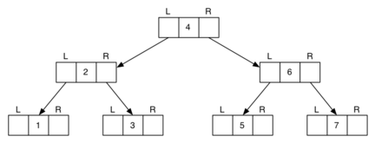

... Representing BSTs | 18/74
Typical data structures for trees …

typedef struct Node *Tree;

typedef struct Node {
int data;
Tree left, right;
} Node;

#define data(tree) ((tree)->data)
#define left(tree) ((tree)->left)
#define right(tree) ((tree)->right)
We ignore items ⇒ data in Node is just a key

... Representing BSTs | 19/74
Abstract data vs concrete data …
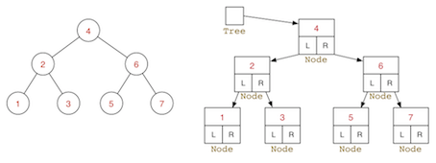

Tree Algorithms

Searching in BSTs | 21/74
Most tree algorithms are best described recursively:
TreeSearch(tree,item):
| Input tree, item
| Output true if item found in tree, false otherwise
|
| if tree is empty then
| return false
| else if item < data(tree) then
| return TreeSearch(left(tree),item)
| else if item > data(tree) then
| return TreeSearch(right(tree),item)
| else
| return true
| end if

Insertion into BSTs | 22/74
Insert an item into appropriate subtree:
insertAtLeaf(tree,item):
| Input tree, item
| Output tree with item inserted
|
| if tree is empty then
| return new node containing item
| else if item < data(tree) then
| return insertAtLeaf(left(tree),item)
| else if item > data(tree) then
| return insertAtLeaf(right(tree),item)
| else
| return tree
| end if

Tree Traversal | 23/74
Iteration (traversal) on …
- Lists … visit each value, from first to last
- Graphs … visit each vertex, order determined by DFS/BFS/…
For binary Trees, several well-defined visiting orders exist:
- preorder (NLR) … visit root, then left subtree, then right subtree
- inorder (LNR) … visit left subtree, then root, then right subtree
- postorder (LRN) … visit left subtree, then right subtree, then root
- level-order … visit root, then all its children, then all their children

... Tree Traversal | 24/74
Consider "visiting" an expression tree like:
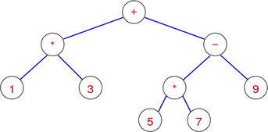
NLR: + * 1 3 - * 5 7 9 (prefix-order: useful for building tree)
LNR: 1 * 3 + 5 * 7 - 9 (infix-order: "natural" order)
LRN: 1 3 * 5 7 * 9 - + (postfix-order: useful for evaluation)
Level: + * - 1 3 * 9 5 7 (level-order: useful for printing tree)

Exercise #2: Tree Traversal | 25/74
Show NLR, LNR, LRN traversals for the following tree:


NLR (preorder): 20 10 5 2 14 12 17 30 24 29 32 31
LNR (inorder): 2 5 10 12 14 17 20 24 29 30 31 32
LRN (postorder): 2 5 12 17 14 10 29 24 31 32 30 20

Exercise #3: Non-recursive traversals | 27/74
Write a non-recursive preorder traversal algorithm.
Assume that you have a stack ADT available.

showBSTreePreorder(t):
| Input tree t
|
| push t onto new stack S
| while stack is not empty do
| | t=pop(S)
| | print data(t)
| | if right(t) is not empty then
| | push right(t) onto S
| | end if
| | if left(t) is not empty then
| | push left(t) onto S
| | end if
| end while

Joining Two Trees | 29/74
An auxiliary tree operation …
Tree operations so far have involved just one tree.
An operation on two trees: t = joinTrees(t₁,t₂)
- Pre-conditions:
  - takes two BSTs; returns a single BST
  - max(key(t₁)) < min(key(t₂))
- Post-conditions:
  - result is a BST (i.e. fully ordered)
  - containing all items from t₁ and t₂

... Joining Two Trees | 30/74
Method for performing tree-join:
- find the min node in the right subtree (t₂)
- replace min node by its right subtree
- elevate min node to be new root of both trees
Advantage: doesn't increase height of tree significantly
x ≤ height(t) ≤ x+1, where x = max(height(t₁),height(t₂))
Variation: choose deeper subtree; take root from there.

... Joining Two Trees | 31/74
Joining two trees:
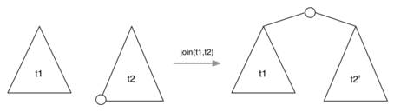

Note: t2' may be less deep than t2

... Joining Two Trees | 32/74
Implementation of tree-join:
joinTrees(t₁,t₂):
| Input trees t₁,t₂
| Output t₁ and t₂ joined together
|
| if t₁ is empty then return t₂
| else if t₂ is empty then return t₁
| else
| | curr=t₂, parent=NULL
| | while left(curr) is not empty do
| | parent=curr
| | curr=left(curr)
| | end while
| | if parent≠NULL then
| | left(parent)=right(curr)
| | right(curr)=t₂
| | end if
| | left(curr)=t₁
| | return curr
| end if

Exercise #4: Joining Two Trees | 33/74
Join the trees
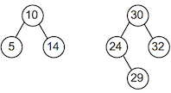

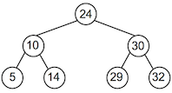

Deletion from BSTs | 35/74
Insertion into a binary search tree is easy.
Deletion from a binary search tree is harder.
Four cases to consider …
- empty tree … new tree is also empty
- zero subtrees … unlink node from parent
- one subtree … replace by child
- two subtrees … replace by successor, join two subtrees

... Deletion from BSTs | 36/74
Case 2: item to be deleted is a leaf (zero subtrees)
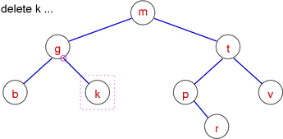
Just delete the item

... Deletion from BSTs | 37/74
Case 2: item to be deleted is a leaf (zero subtrees)
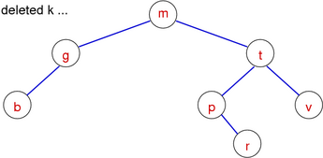

... Deletion from BSTs | 38/74
Case 3: item to be deleted has one subtree
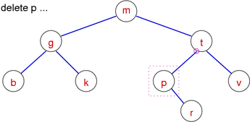
Replace the item by its only subtree

... Deletion from BSTs | 39/74
Case 3: item to be deleted has one subtree
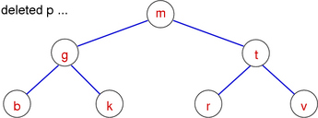

... Deletion from BSTs | 40/74
Case 4: item to be deleted has two subtrees
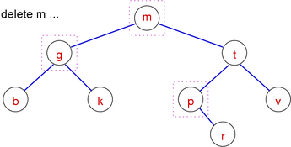
Version 1: right child becomes new root, attach left subtree to min element of right subtree

... Deletion from BSTs | 41/74
Case 4: item to be deleted has two subtrees
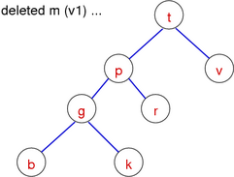

... Deletion from BSTs | 42/74
Case 4: item to be deleted has two subtrees
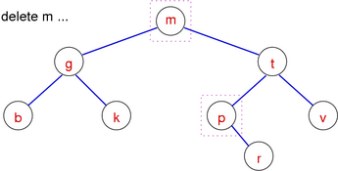
Version 2: join left and right subtree

... Deletion from BSTs | 43/74
Case 4: item to be deleted has two subtrees
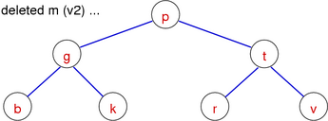

... Deletion from BSTs | 44/74
Pseudocode (version 2):
TreeDelete(t,item):
| Input tree t, item
| Output t with item deleted
|
| if t is not empty then
| | if item < data(t) then
| | left(t)=TreeDelete(left(t),item)
| | else if item > data(t) then
| | right(t)=TreeDelete(right(t),item)
| | else
| | | if left(t) and right(t) are empty then
| | | new=empty tree
| | | else if left(t) is empty then
| | | new=right(t)
| | | else if right(t) is empty then
| | | new=left(t)
| | | else
| | | new=joinTrees(left(t),right(t))
| | | end if
| | | free memory allocated for t
| | | t=new
| | end if
| end if
| return t

Balanced BSTs

Balanced Binary Search Trees | 46/74
Goal: build binary search trees which have
- minimum height ⇒ minimum worst case search cost
Perfectly balanced tree with N nodes has
- abs(#nodes(LeftSubtree) - #nodes(RightSubtree)) < 2, for every node
- height of log₂N ⇒ worst case search O(log N)
Three strategies to improving worst case search in BSTs:
- randomise — reduce chance of worst-case scenario occuring
- amortise — do more work at insertion to make search faster
- optimise — implement all operations with performance bounds

Operations for Rebalancing | 47/74
To assist with rebalancing, we consider new operations:
Left rotation
- move right child to root; rearrange links to retain order
Right rotation
- move left child to root; rearrange links to retain order
Insertion at root
- each new item is added as the new root node

Tree Rotation | 48/74
In tree below: t₁ < n₂ < t₂ < n₁ < t₃
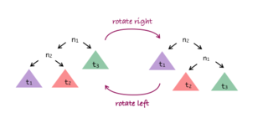

... Tree Rotation | 49/74
Method for rotating tree T right:
- N₁ is current root; N₂ is root of N₁'s left subtree
- N₁ gets new left subtree, which is N₂'s right subtree
- N₁ becomes root of N₂'s new right subtree
- N₂ becomes new root
Left rotation: swap left/right in the above.
Cost of tree rotation: O(1)

... Tree Rotation | 50/74
Algorithm for right rotation:
rotateRight(n₁):
| Input tree n₁
| Output n₁ rotated to the right
|
| if n₁ is empty ∨ left(n₁) is empty then
| return n₁
| end if
| n₂=left(n₁)
| left(n₁)=right(n₂)
| right(n₂)=n₁
| return n₂


Exercise #5: Tree Rotation | 51/74
Consider the tree t:

Show the result of rotateRight(t)

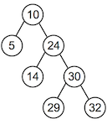

Exercise #6: Tree Rotation | 53/74
Write the algorithm for left rotation


rotateLeft(n₂):
| Input tree n₂
| Output n₂ rotated to the left
|
| if n₂ is empty ∨ right(n₂) is empty then
| return n₂
| end if
| n₁=right(n₂)
| right(n₂)=left(n₁)
| left(n₁)=n₂
| return n₁

Insertion at Root | 55/74
Previous description of BSTs inserted at leaves.
Different approach: insert new item at root.
Potential disadvantages:
- large-scale rearrangement of tree for each insert
Potential advantages:
- recently-inserted items are close to root
- low cost if recent items more likely to be searched

... Insertion at Root | 56/74
Method for inserting at root:
- base case:
  - tree is empty; make new node and make it root
- recursive case:
  - insert new node as root of appropriate subtree
  - lift new node to root by rotation

... Insertion at Root | 57/74
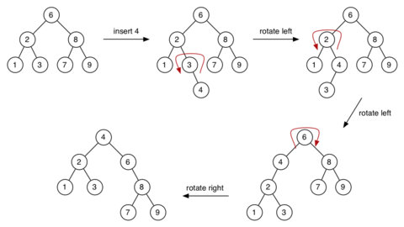

Exercise #7: Insertion at Root | 58/74
Consider the tree t:
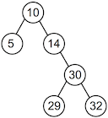
Show the result of insertAtRoot(t,24)



... Insertion at Root | 60/74
Analysis of insertion-at-root:
- same complexity as for insertion-at-leaf: O(height)
- tendency to be balanced, but no balance guarantee
- benefit comes in searching
  - for some applications, search favours recently-added items
  - insertion-at-root ensures these are close to root
- could even consider "move to root when found"
  - effectively provides "self-tuning" search tree

Rebalancing Trees | 61/74
An approach to balanced trees:
- insert into leaves as for simple BST
- periodically, rebalance the tree
Question: how frequently/when/how to rebalance?
NewTreeInsert(tree,item):
| Input tree, item
| Output tree with item randomly inserted
|
| t=insertAtLeaf(tree,item)
| if #nodes(t) mod k = 0 then
| t=rebalance(t)
| end if
| return t
E.g. rebalance after every 20 insertions ⇒ choose k=20
Note: To do this efficiently we would need to change tree data structure and basic operations:

typedef struct Node {
int data;
int nnodes;
Tree left, right;
} Node;

... Rebalancing Trees | 62/74
How to rebalance a BST? Move median item to root.
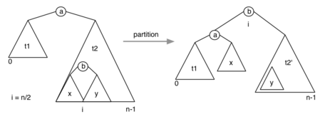

... Rebalancing Trees | 63/74
Implementation of rebalance:
rebalance(t):
| Input tree t with n nodes
| Output t rebalanced
|
| if n≥3 then
| | t=partition(t,n/2)
| | left(t)=rebalance(left(t))
| | right(t)=rebalance(right(t))
| end if
| return t

... Rebalancing Trees | 64/74
New operation on trees:
- partition(tree,i): re-arrange tree so that element with index i becomes root
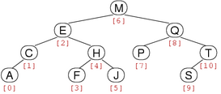
For tree with N nodes, indices are 0 .. N-1

... Rebalancing Trees | 65/74
Partition: moves i ^{th} node to root
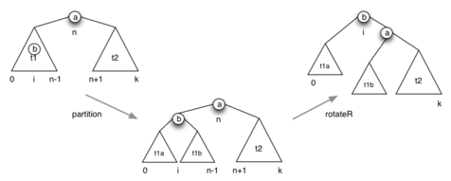

... Rebalancing Trees | 66/74
Implementation of partition operation:
partition(tree,i):
| Input tree with n nodes, index i
| Output tree with i^{th} item moved to the root
|
| m=#nodes(left(tree))
| if i < m then
| left(tree)=partition(left(tree),i)
| tree=rotateRight(tree)
| else if i > m then
| right(tree)=partition(right(tree),i-m-1)
| tree=rotateLeft(tree)
| end if
| return tree
Note: size(tree) = n, size(left(tree)) = m, size(right(tree)) = n-m-1 (why -1?)

Exercise #8: Partition | 67/74
Consider the tree t:

Show the result of partition(t,3)

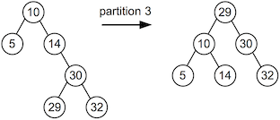

... Rebalancing Trees | 69/74
Analysis of rebalancing: visits every node ⇒ O(N)
Cost means not feasible to rebalance after each insertion.
When to rebalance? … Some possibilities:
- after every k insertions
- whenever "imbalance" exceeds threshold
Either way, we tolerate worse search performance for periods of time.
Does it solve the problem? … Not completely ⇒ Solution: real balanced trees (next week)

Application of BSTs: Sets | 70/74
Trees provide efficient search.
Sets require efficient search
- to find where to insert/delete
- to test for set membership
Logical to implement a set ADT via BSTree

... Application of BSTs: Sets | 71/74
Assuming we have Tree implementation
- which precludes duplicate key values
- which implements insertion, search, deletion
then Set implementation is
- SetInsert(Set,Item) ≡ TreeInsert(Tree,Item)
- SetDelete(Set,Item) ≡ TreeDelete(Tree,Item.Key)
- SetMember(Set,Item) ≡ TreeSearch(Tree,Item.Key)

... Application of BSTs: Sets | 72/74
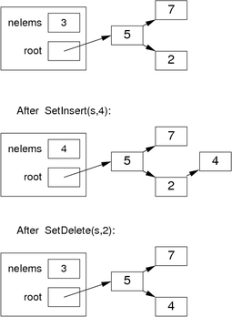

... Application of BSTs: Sets | 73/74
Concrete representation:
#include <BSTree.h>

typedef struct SetRep {
int nelems;
Tree root;
} SetRep;

Set newSet() {
Set S = malloc(sizeof(SetRep));
assert(S != NULL);
S->nelems = 0;
S->root = newTree();
return S;
}

Summary | 74/74
- Binary search tree (BST) data structure
- BST insertion and deletion
- Other tree operations
  - tree rotation
  - tree partition
  - joining trees

- Suggested reading:
  - Sedgewick, Ch.12.5-12.6,12.8-12.9

Produced: 3 Jan 2018

